**Name : Sonu Login Id: KOCHCEAPB206**

**Docker Case Study Assessment**

**As part of this case study, we would like to containerize an application that prints the following**

**echo ---------------------**

**echo System Parameters**

**echo ---------------------**

**echo My name is:**

**echo $(hostname)**

**echo ---------------------**

**echo I''m running on:**

**echo $(uname -s -r -m)**

**echo ---------------------**

**echo My address is:**

**echo $(ifconfig eth0 | grep inet)**

**echo ---------------------**

**Please refer the code “cmd.sh”. We would like to create an image and publish the image to dockerhub.**

1. **Task1: Containerize application using docker - 70 marks**
   1. Create a dockerfile for the file “cmd.sh”
      1. Set base image as alpline:latest
      2. Set working directory as app
      3. Copy cmd.sh to app
      4. Set CMD accordingly so that container prints the above text
      5. Build the dockerfile and tag the image with a name.
      6. Create a container for the above image.
   2. Publish the image, created from above step, to Dockerhub

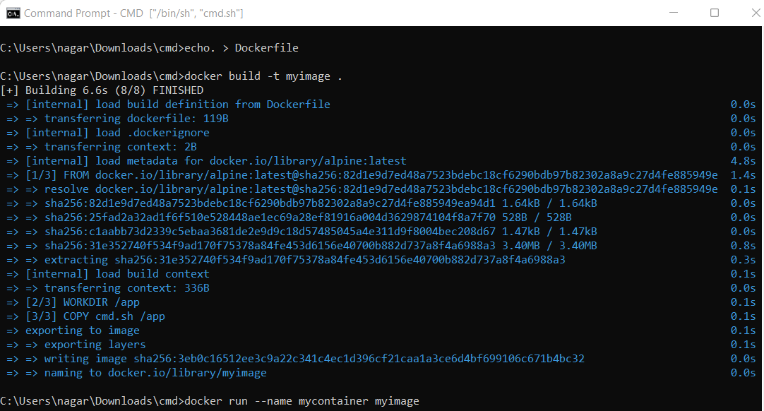

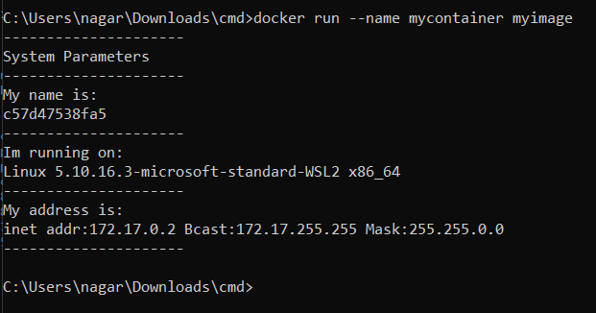

1. **Task 2: Create a repository in github and upload the files from above task - 30 marks**
   1. Create a repository in github.
   2. Push the files “cmd.sh” and “Dockerfile” to github repository created in the above step.

**Submission guidelines:**

1. Take a screenshot of every step clearly in a word document with commands(if applicable).
2. Mention your name and login ID at the top of the document.
3. Convert Word doc as PDF and upload it on LMS.